

Six Weeks Training Report on

Web Development

by

Mr. Amey Rajendra Sankhe

ROLL NO: 1209

UNDER THE GUIDENCE OF

PROF. Rajesh Garud

DEPARTMENT OF COMPUTER ENGINEERING

**Abstract**

Webwork Solutions is a company trying to reduce the skill gap in the industry of the new developers. After students complete their diploma or degree, they generally have no idea about the new technologies in the industry due to which it becomes difficult to adapt in the industry.

Webwork Solutions has taught me Web development which includes frontend technologies such as HTML, CSS, JavaScript, jQuery, WordPress, Xamp, Webhosting and Domain.

I have implemented above technologies and created various project such as Responsive webpages, E-commerce landing page, Simple and EMI calculator.

We not only learned the language and technologies but also how they work behind the hood, their uses in industries and their history.

**Acknowledgment**

This acknowledgement transcends the reality of formality where we would like to express deep gratitude and respect to all those people behind the screen who guided, inspired and helped us for the completion of our project work.

This project would add as an asset to our academic profile. We express our sincere gratitude to our respectful Principal Dr. Shubhada Gadgil for enabling us to make use of laboratory and library facilities liberally, that helped us a long way in carrying out our project work successfully.

We consider ourselves lucky enough to get such a good project. This project would add as an asset to our academic profile. We express our gratitude to yhe help of the Head of the Department of the Computer Engineering, Mr. Parvez Vaghela, for his constant supervision, guidance and co-operation throughout the project and we would like to express our thankfulness to our project guide, Mr. Rajesh Garud for his constant motivation and valuable help through the project work. We extend our sincere gratitude to our parents who have encouraged us with their blessings to do this internship successfully.

**Certificate**

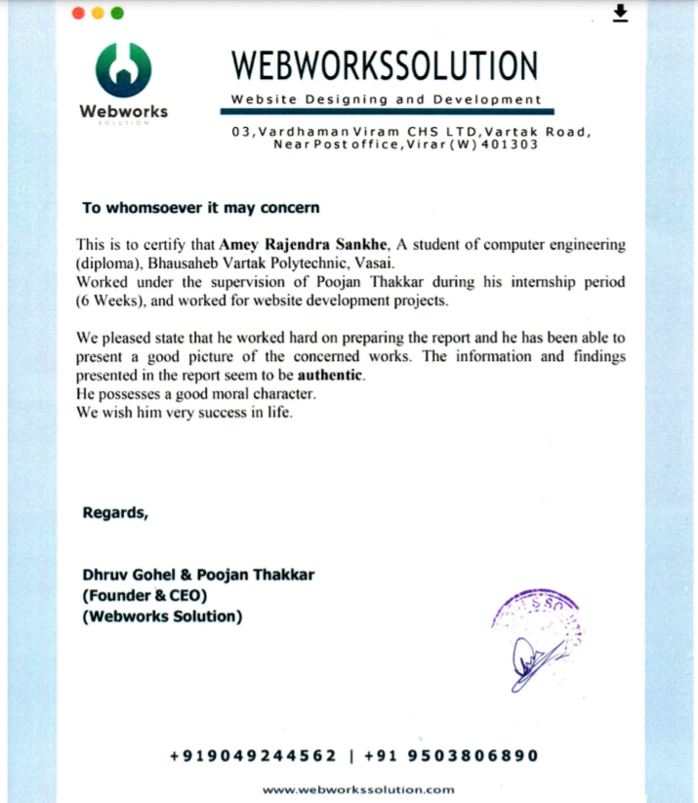

**Index**

|  |  |
| --- | --- |
| **No. of weeks** | **Topics Covered** |
| 1 | Introduction to HTML5, CSS and Java Script. |
| 2 | HTML5**.** |
| 3 | CSS. |
| 4 | JavaScript. |
| 5 | Jquery. |
| 6 | Word press & XAMP. |

**Industrial Training Report**

Name: Amey Rajendra Sankhe.

Roll No.: 1209

Company name: Webworks Solution

1. Introduction

I am currently interning in the company named Webwork Solutions. This internship is based on web development which includes computer languages like HTML (Hypertext markup language),CSS(Cascading style sheets) and Java script.



Web development is the work involved in developing a Web site for the Internet (World Wide Web) or an intranet (a private network).Web development can range from developing a simple single static page of plain text to complex web applications, electronic businesses, and social network services. A more comprehensive list of tasks to which Web development commonly refers, may include Web engineering, Web design, Web content development, client liaison, client-side/server-side scripting, Web server and network security configuration, and e-commerce development.

An ever-growing set of tools and technologies have helped developers build more dynamic and interactive Web sites. Further, Web developers now help to deliver applications as Web services which were traditionally only available as applications on a desk-based computer. This has allowed for many opportunities to decentralize information and media distribution and it is also one of the easiest accessible higher paid fields as you do not need a traditional University degree to become eligible for a job.

1. Report - Week 1.

* DAY 1

Lecture Timing – 8:00 am to 10:00 am

* Topics covered in the lecture:

1. Introduction to HTML,CSS and JavaScript.
2. HTML web page structure
3. HTML tags.
4. HTML tables.
5. HTML lists.
6. HTML image syntax.
7. HTML hyperlinks and text formatting.

* Self study :

Timing: 2:00 pm to 4:00 pm

1. Revision of above topics.
2. Performing programs by using basic html in Microsoft VS code.

* DAY 2

Lecture Timing – 8:00 am to 10:00am

* Topics covered in the lecture:

1. Detailed explanation of HTML tables.
2. Various elementsments and applications of HTML tables which includes:
   1. Table data,table row and table column.
   2. Cellspacing,cellpadding and rowspan,colspan.
   3. Making image gallery by using table tags.
3. Designing of forms.
4. Assigned task:

Create an HTML website with basic html which includes tables and additional pages like About us, Contact and register. The task could be performed individually or by a group of maximum 4 members.

* Self study :

Timing: 2:00pm to 4:00pm

1. Revision of above topics.
2. Performing programs by using basic html in Microsoft vs code.

Timing: 6:00pm to 9:00pm

1. Completion of assigned task.

* Day 3

Lecture Timing – 8:00am – 10:00am

* Topics covered in the lecture:

1. Introduction to CSS.
2. External CSS.
3. Inline CSS.
4. Embedded CSS.
5. Presentation of assigned task.
6. Assigned task:

Creating an HTML website with basic html which includes tables and additional pages like About us, Contact and register. The task must be performed individually.

* Self study:

Timing: 2:00 pm to 4:00pm

1. Revision of above topics.
2. Performing programs by using CSS in Microsoft VS code.

Timing: 6:00pm to 9:00 pm

1. Completion of assigned task.

* Day 4
* Self study:

Timing:10:00am to 12:00 pm

1. Revision of entire topics covered in the whole week.
2. Performing programs by using HTML and CSS in Microsoft VS code.

Timing:3:00pm to 6:00pm

1. Completion of assigned task.

* Day 5

Submission of assigned task at 3:00pm

* Self study:

Timing:10:00am to 1:00pm

1. Completion of assigned task.

Timing:6:00pm to 8:00pm

1. Revision of entire topics covered in the whole week.
2. Performing programs by using HTML and CSS in Microsoft VS code.

* Day 6

We were informed about the review of our project submitted to the company via whatsapp.

* Self study:

Timing:10:00am to 12:00am

1. Revision of entire topics covered in the whole week.
2. Performing programs by using HTML and CSS in Microsoft VS code.

Timing:5:00pm to 6:00pm

1. Completion of assigned task.

* Day 7
* Self study:

1. Revision of entire topics covered in the whole week.
2. Performing programs by using HTML and CSS in Microsoft VS code.
3. Report - Week 2.

* DAY 1

Lecture Timing – 8:00 am to 10:00 am

* Topics covered in the lecture:

a)Introduction to CSS.

b)Internal CSS.

c)Inline CSS.

d)External CSS.

e)Container Tags.

f)Designing Buttons.

g)Text and Font.

* Self study :

Timing: 2:00 pm to 4:00 pm

1. Revision of above topics.
2. Performing programs by using basic html & css in Microsoft VS code.

* DAY 2

Lecture Timing – 8:00 am to 10:00am

* Topics covered in the lecture:

a)Use of animations.

b)Inclusion of audio & video.

c)Hover and Opacity.

Create an HTML and CSS website with html and internal css but the page should be designed according to the layout provided by the company. The task must be performed individually.

* Self study :

Timing: 2:00pm to 4:00pm

a) Revision of above topics.

b) Performing programs by using html and css in Microsoft vs code.

Timing: 6:00pm to 9:00pm

1. Completion of assigned task.

* Day 3

Lecture Timing – 8:00am – 10:00am

* Topics covered in the lecture:

1. Presentation of assigned task.
2. Assigned task:

Creating an HTML and CSS website with html and css but the page should be designed according to the layout provided by the company and add other pages like about us,contact and register are optional. The task must be performed individually.

* Self study:

Timing: 2:00 pm to 4:00pm

1. Revision of above topics.
2. Performing programs by using HTML & CSS in Microsoft VS code.

Timing: 6:00pm to 9:00 pm

1. Completion of assigned task.

* Day 4
* Self study:

Timing:10:00am to 12:00 pm

1. Revision of entire topics covered in the whole week.
2. Performing programs by using HTML and CSS in Microsoft VS code.

Timing:3:00pm to 6:00pm

1. Completion of assigned task.

* Day 5

Submission of assigned task at 3:00pm

* Self study:

Timing:10:00am to 1:00pm

1. Completion of assigned task.

Timing:6:00pm to 8:00pm

1. Revision of entire topics covered in the whole week.
2. Performing programs by using HTML and CSS in Microsoft VS code.

* Day 6

We were informed about the review of our project submitted to the company via whatsapp.

* Self study:

Timing:10:00am to 12:00am

1. Revision of entire topics covered in the whole week.
2. Performing programs by using HTML and CSS in Microsoft VS code.

Timing:5:00pm to 6:00pm

1. Completion of assigned task.

* Day 7
* Self study:

1. Revision of entire topics covered in the whole week.
2. Performing programs by using HTML and CSS in Microsoft VS code.
3. Report - Week 3.

* DAY 1

Lecture Timing – 10:00 am to 12:00 pm

* Topics covered in the lecture:

a)CSS padding and margin properties.

b)Types of CSS selectors.

c)Positioning property.

d)Display property.

* Self study :

Timing: 2:00 pm to 4:00 pm

1. Revision of above topics.
2. Performing programs by using basic html & css in Microsoft VS code.

* DAY 2

Lecture Timing – 10:00 am to 12:00pm

* Topics covered in the lecture:

a)Use of semantic elements.

b)Introduction to javascript.

c)Use of arithmetic operators in javascript.

Write javascript programs to display result of arithmetic operators and check whether they are valid or invalid.

* Self study :

Timing: 2:00pm to 4:00pm

a) Revision of above topics.

b) Performing programs by using html and css in Microsoft vs code.

Timing: 6:00pm to 7:00pm

1. Completion of assigned task.

* Day 3

Lecture Timing – 11:00am – 1:00pm

* Topics covered in the lecture:

a)Operators:

1.Relational.

2.Logical.

3.Increment & decrement.

b)Comments in javascript.

c)Functions.

d)Decision making statements.

1. Assigned task:

Create a HTML website using semantic tags.

* Self study:

Timing: 2:00 pm to 4:00pm

1. Revision of above topics.
2. Performing programs by using HTML & CSS in Microsoft VS code.

Timing: 6:00pm to 9:00 pm

1. Completion of assigned task.

* Day 4
* Self study:

Timing:10:00am to 12:00 pm

1. Revision of entire topics covered in the whole week.
2. Performing programs by using HTML and CSS in Microsoft VS code.

Timing:3:00pm to 6:00pm

1. Completion of assigned task.

* Day 5

Submission of assigned task at 3:00pm

* Self study:

Timing:10:00am to 1:00pm

1. Completion of assigned task.

Timing:6:00pm to 8:00pm

1. Revision of entire topics covered in the whole week.
2. Performing programs by using HTML and CSS in Microsoft VS code.

* Day 6

We were informed about the review of our project submitted to the company via whatsapp.

* Self study:

Timing:10:00am to 12:00am

1. Revision of entire topics covered in the whole week.
2. Performing programs by using HTML and CSS in Microsoft VS code.

Timing:5:00pm to 6:00pm

1. Completion of assigned task.

* Day 7
* Self study:

1. Revision of entire topics covered in the whole week.
2. Performing programs by using HTML and CSS in Microsoft VS code.
3. Report - Week 4.

* DAY 1

Lecture Timing – 11:00 am to 1:00 pm

* Topics covered in the lecture:

a)Types of loops.

b)Nested statements.

c)Use of prompt in javascript.

d)Assigned tasks:

1) Program on Do-while loop.

2) Program to display prime numbers.

* Self study :

Timing: 2:00 pm to 4:00 pm

1. Revision of above topics.
2. Performing programs by using basic html & css in Microsoft VS code.

Timing:3:00pm to 6:00pm

1. Completion of assigned task.

* DAY 2
* Self study :

Timing: 2:00pm to 4:00pm

a) Revision of above topics.

b) Performing programs by using html and css in Microsoft vs code.

Timing: 6:00pm to 8:00pm

1. Completion of assigned task.

* Day 3

Lecture Timing – 11:00am – 1:00pm

* Topics covered in the lecture:

a)Objects in javascript:

1.Defined Objects.

2.User defined Objects.

3.DOM(Document object model).

b)Event handling in javascript.

c)Assigned task:

Write Javascript program to set three different background color to webpage on onclick, onMousemove and onMouseover events of button object.

* Self study:

Timing: 2:00 pm to 4:00pm

1. Revision of above topics.
2. Performing programs by using HTML & CSS in Microsoft VS code.

Timing: 6:00pm to 9:00 pm

1. Completion of assigned task.

* Day 4
* Self study :

Timing: 2:00pm to 4:00pm

a) Revision of above topics.

b) Performing programs by using html and css in Microsoft vs code.

Timing: 6:00pm to 8:00pm

1. Completion of assigned task.

* Day 5

Lecture Timing – 11:00am – 1:00pm

* Topics covered in the lecture:

a)Built-in objects:

1)String.

2)Math.

3)Date & Number.

4)Array.

c)Assigned task:

Write Javascript program to create a simple and a EMI calculator.

* Self study:

Timing: 2:00 pm to 4:00pm

a)Revision of above topics.

b)Performing programs by using HTML & CSS in Microsoft VS code.

Timing: 6:00pm to 9:00 pm

c)Completion of assigned task.

* Day 6
* Self study:

Timing:10:00am to 12:00am

a)Revision of entire topics covered in the whole week.

b)Performing programs by using HTML and CSS in Microsoft VS code.

c)Completion of assigned task:

Timing:5:00pm to 7:00pm

* Day 7
* Self study:

1. Revision of entire topics covered in the whole week.
2. Performing programs by using HTML and CSS in Microsoft VS code.

Timing:5:00pm to 8:00pm

1. Completion of assigned task.
2. Report - Week 5.

* DAY 1

Lecture Timing – 3:00 pm to 5:00 pm

* Topics covered in the lecture:

a)How to use wordpress for creating websites.

b)Use and working of Domain.

c)Use of Web hosting and its working.

d)Assigned tasks:

Use Github to make your website accesable for all.

* Self study :

Timing: 2:00 pm to 4:00 pm

a)Revision of above topics.

b)Performing programs by using basic html & css in Microsoft VS code.

Timing:3:00pm to 6:00pm

c)Completion of assigned task.

* DAY 2

Lecture Timing : 5:00pm to 7:00pm

* Topics covered in the lecture:

a)jQuery selectors.

b)Event handling.

c)Effects using jquery.

1)Hide

2)Show

3)Toggle

4)Slide

5)Animate

* Self study :

a) Revision of above topics.

b) Performing programs by using html, CSS and jQuery in Microsoft vs code.

* Day 3

Lecture Timing – 11:00am – 1:00pm

* Topics covered in the lecture:

a) DOM manipulation methods.

b) Dimensions of jQuery.

c) Assigned task:

Write JavaScript program to create a simple calculator and EMI calculator.

* Self-study:

Timing: 2:00 pm to 4:00pm

1. Revision of above topics.
2. Performing programs by using HTML, CSS and jQuery in Microsoft VS code.

Timing: 6:00pm to 9:00 pm

1. Completion of assigned task.

* Day 4

Lecture Timing – 11:00am – 1:00pm

* Topics covered in the lecture:

1. Presentation of assigned task.
2. Assigned task:

Create a website using all the topics covered in the internship. Use folder structure for proper access to the code and for performing web hosting and domain activities on your project.

* Self study :

Timing: 2:00pm to 4:00pm

a) Revision of topics covered in the entire week.

b) Performing programs by using html and css in Microsoft vs code.

Timing: 6:00pm to 9:00 pm

1. Completion of assigned task.
2. Report - Week 6.

* DAY 1

Lecture Timing – 3:00 pm to 5:00 pm

* Topics covered in the lecture:

a)Presentation of assigned task.

b)Web Hosting.

1)Prerequisites for free Web Hosting.

2)Steps to acquire free webspace.

* Self study :

Timing: 2:00 pm to 4:00 pm

a)Revision of above topics.

b)Performing programs by using basic html & css in Microsoft VS code.

* DAY 2

Lecture Timing : 5:00pm to 7:00pm

* Topics covered in the lecture:

a)Use of Domain.

1) Redirecting domain to free server.

2) Park the website domain.

* Self study :

a) Revision of above topics.

b) Performing programs by using html, CSS and jQuery in Microsoft vs code.

* Day 3

Lecture Timing – 11:00am – 1:00pm

* Topics covered in the lecture:

a) Performing web hosting on our project.

b) Adding templates from wordpress to our project.

c) Use of XAMP.

d) Assigned task:

Make your projects more presentable by using templates from wordpress.

* Self-study:

Timing: 2:00 pm to 4:00pm

1. Revision of above topics.
2. Performing programs by using HTML, CSS and jQuery in Microsoft VS code.

Timing: 6:00pm to 9:00 pm

1. Completion of assigned task.

* Day 4

Lecture Timing – 11:00am – 1:00pm

* Topics covered in the lecture:

1. Presentation of assigned task.
2. Use of control panel in wordpress.
3. Modifying templates.

* Self study :

Timing: 2:00pm to 4:00pm

a) Revision of topics covered in the entire week.

b) Performing programs by using html and css in Microsoft vs code.

1. Final Project.

* Program:

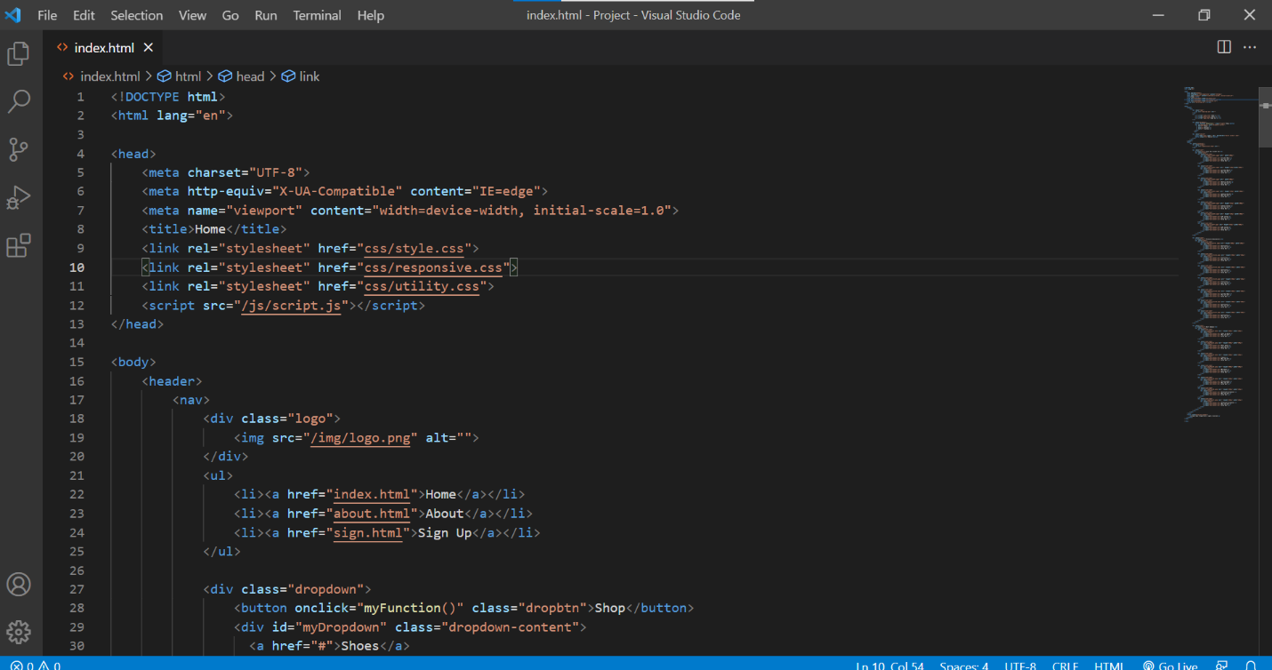

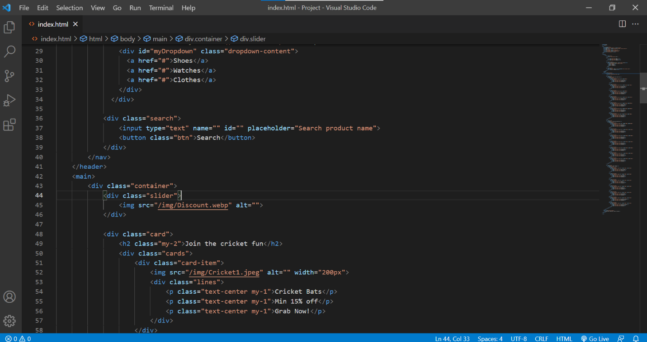

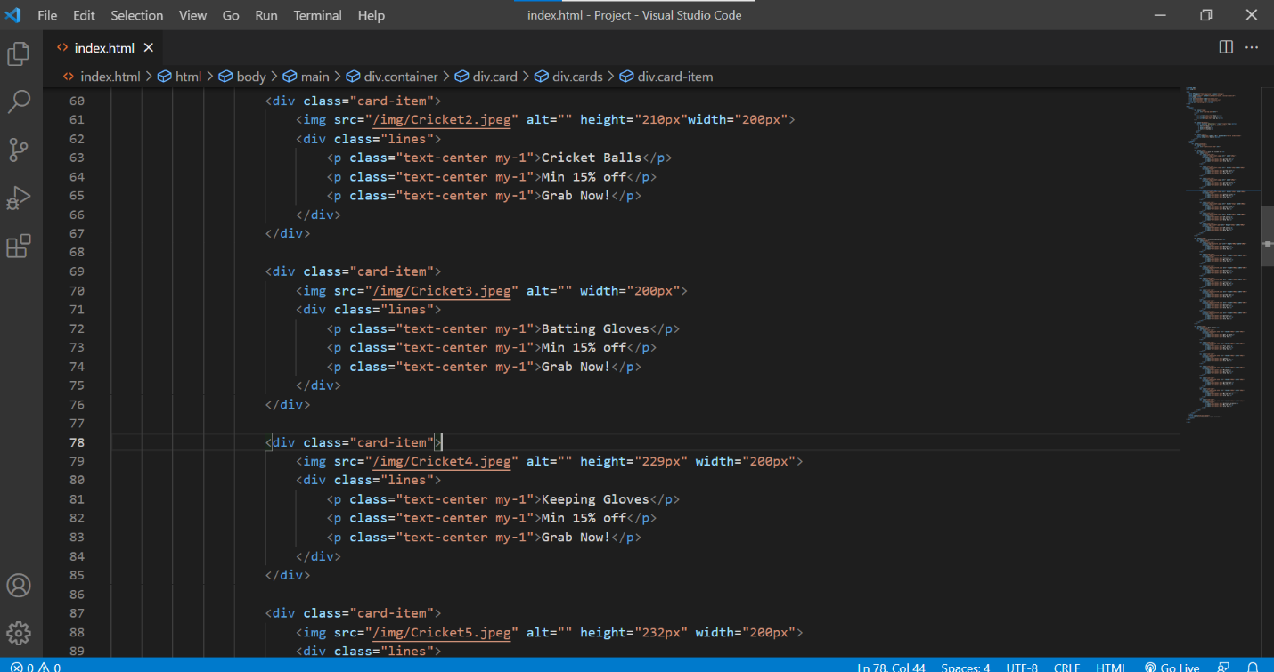

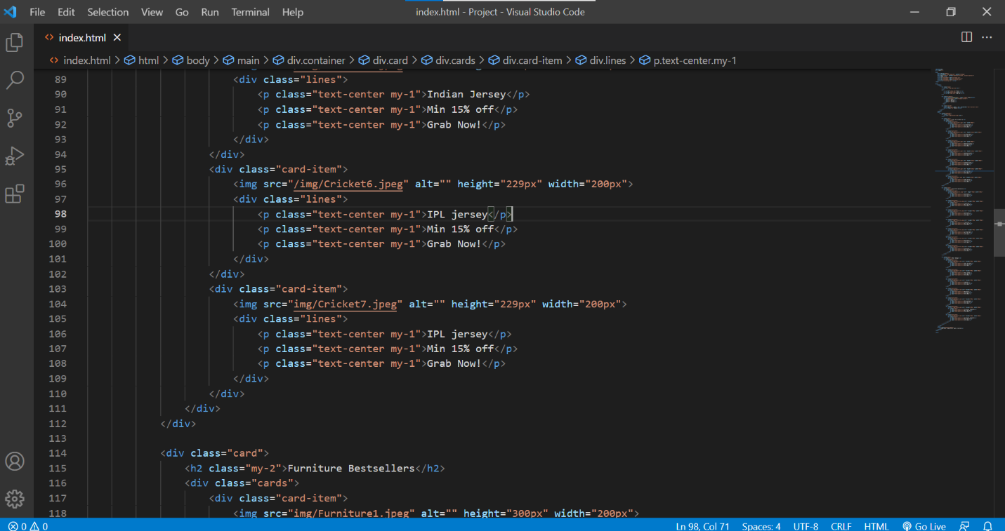

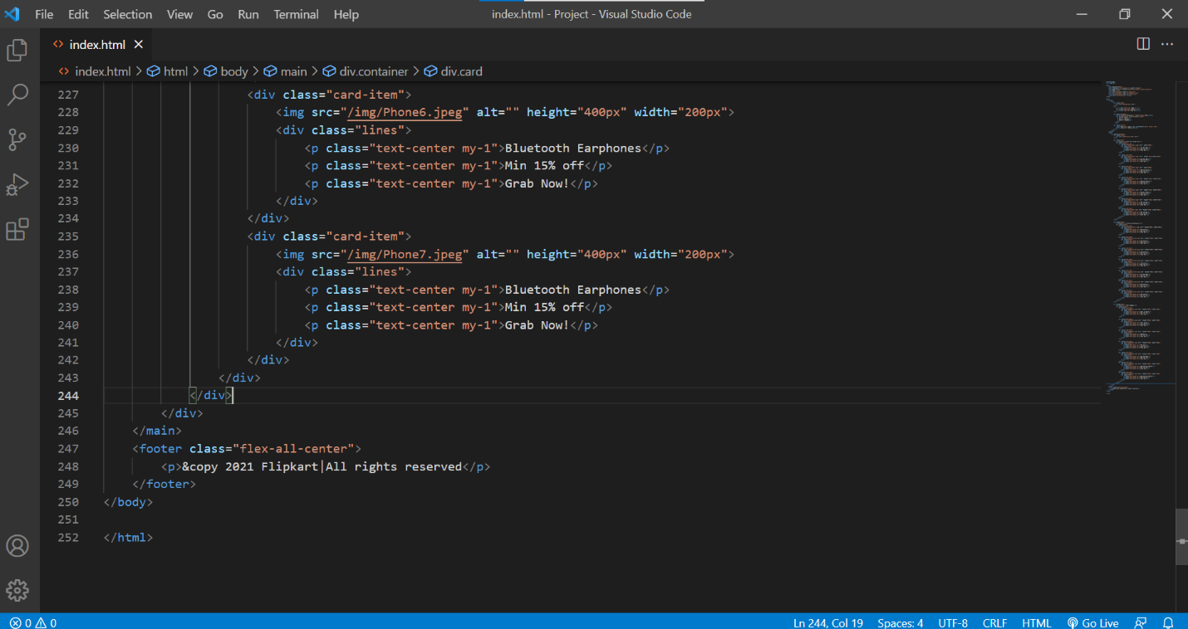

* Output:

